Fortescue Zero
Scouts Electronics Activity Badge
[Document subtitle]
Philip McGaw
[Date]

How to earn your badge:
- Identify several common electronic components that are shown to you.
  - Explain, in simple terms, the functions they perform in electronic circuits.
- Describe the systems used for marking components with their values
  - Demonstrate by identifying the values of resistors and capacitors by their markings. Explain the importance of the rating of a component.
- Show that you know the symbols used to represent common components in circuit diagrams.
  - Show how to identify the polarity of a diode and a specific PIN on an integrated circuit.
- Show that you’re aware of the safe working practices to be followed when handling electronic components, circuit boards and when soldering.
- Use a multimeter to measure voltage, current and resistance in a simple circuit.
  - Explain the relationship between these values.
- Talk about the main differences in the operation of digital and analogue circuits.
- Construct three simple circuits.
  - One of these should be based mainly on digital electronics. They can be from a book or magazine, or you can design the circuits yourself. If possible, at least one of the circuits should be soldered using either stripboard or a custom-made printed circuit board.
- Explain the principles behind the operation of each circuit and the typical values of voltage and current found in each.
- Explain the possible uses of the three circuits you built.
- Talk about the uses and benefits of electronics in everyday life.
  - Explain how electronics can be used to improve lives.

ANSI and IEC/ISO Electronics Symbols
You may see more than one accepted symbol for the same electronic component. In the UK and Europe, diagrams often follow IEC conventions, especially the IEC 60617 graphical-symbol system. In North American material, you may see ANSI-based conventions or related US drawing standards. These systems are not a completely different language: many symbols are similar, but some shapes and drawing details differ.
Common examples include a resistor drawn as a rectangle in IEC-style diagrams or as a zigzag in many North American diagrams. Switches, grounds, capacitors, batteries, and logic symbols can also be drawn differently. A symbol’s meaning comes from the whole schematic, its labels, and the convention used by the author.
For this booklet, learn the symbol shown in each diagram and be able to recognise the most common alternative. Do not mix conventions in one drawing unless you label the parts clearly. When copying a circuit from a book, website, or datasheet, follow that source’s symbol convention and check the legend if one is provided.
Best Practices for Engineering Documentation
- Do Not Mix: Never combine ANSI and IEC symbols within the same schematic diagram, as it creates ambiguity for technicians and builders

History and Introduction
Electronics is the science that controls the behaviour of electrons so that some type of useful function is performed. (Electrons will be explained more fully later in this book.) Today, electronics is a fast-changing and exciting field. The rapid growth of electronics started in the early 20th century when vacuum tubes were introduced and used to manipulate electronic signals. This was something that could not be done with the telegraph and telephone circuits or the high-voltage transmitters of those days. Vacuum tubes allowed weak radio and powerful signals to be amplified, or to be made louder or stronger, and be sent on powerful waves.
Electronics changed even more dramatically in 1948 when the transistor, a small, low-powered, solid-state electronic device, was invented. Transistors are smaller than vacuum tubes, require less power to function, and are more reliable. The development of the integrated circuit, or IC, advanced this technology further. ICs can contain tens of thousands of tiny transistors built onto a small piece of conducting material. This allows for the construction and production of complex electronic circuits, which are more efficient than tubes in processing electronic signals. ICs are used in many products today, including computers, audio equipment, cell phones, appliances, and automobiles.

How to Earn the Electronics Scout Badge
The first step in earning your Electronics Scout Badge is to discuss the requirements with your Scout Leader. This booklet is written for Scouts and Explorers aged approximately 10 to 16 and is designed to support practical work with an adult Leader.
For Requirement 1, identify several common electronic components and explain, in simple terms, the functions they perform in a circuit. Use the Component Types and Basic Electronics Theory sections, then complete the Component Identification Activity. Your Leader may show you real components and ask you to name them, describe their functions, and explain how they are used in one of the projects.
For Requirement 2, learn how electronic components are marked with their values. Practise identifying resistor values from colour bands or printed codes and capacitor values from their markings. Explain why a component’s voltage, current, power, tolerance, and polarity ratings matter, and why a replacement must be suitable for the circuit. Use the Colour Code of Resistors, capacitor markings, and Ratings and datasheets sections.
For Requirement 3, learn the symbols used for common components in circuit diagrams. Draw or copy a simple schematic using the correct symbols, and explain what the components do. You must also be able to identify the polarity of a diode or LED and locate a specified pin on an integrated circuit by using its package marking and datasheet. Use the Schematic Diagrams, ANSI and IEC/ISO Electronics Symbols, and Pin Identification sections.
For Requirement 4, show that you understand safe working practices when handling electronic components, circuit boards, batteries, tools, and soldering equipment. Work only with a Leader’s supervision, use low-voltage battery circuits, keep the work area tidy, protect your eyes when cutting or drilling, and follow the soldering safety guidance. Use the Safety First section and the soldering visual guide supplied by your Leader.
For Requirement 5, use a multimeter to measure voltage, current, and resistance in a simple circuit. Explain the relationship between these values, including Ohm’s law, and select the correct meter function, socket, range, and connection method. For Requirement 6, explain the main differences between analogue and digital circuits, using examples such as a changing light-sensor voltage and the HIGH or LOW output of a logic gate. Complete the Using a Multimeter and Analogue and Digital Electronics activities with a Leader.
For Requirements 7 to 9, construct three simple circuits. At least one should be based mainly on digital electronics. Where it can be done safely, solder at least one circuit using stripboard or a custom-made printed circuit board. For each circuit, explain how it works, identify the purpose of its components, record typical voltage and current readings, and describe possible uses. A Leader must approve the circuit, power supply, components, and construction method before you begin.
For Requirement 10, talk about the uses and benefits of electronics in everyday life. Choose examples such as communication, healthcare, transport, accessibility, homes, energy, environmental monitoring, or emergency services. Explain how electronics can solve problems or improve people’s lives, and consider responsibilities such as safety, privacy, repair, energy use, recycling, and battery disposal.
Use the project records and Badge Evidence Checklist to prepare your evidence. You should be able to show your work, explain what you have learned, demonstrate practical skills where appropriate, and answer questions from your Leader. The Leader should verify that the evidence meets the current Scouts UK Electronics Activity Badge requirements.

Tools for Electronics Work
The basic tools you will need for most of your electronics work are shown here. You can probably find some around your home and get others at an electronics parts store.
Some Basic Tools
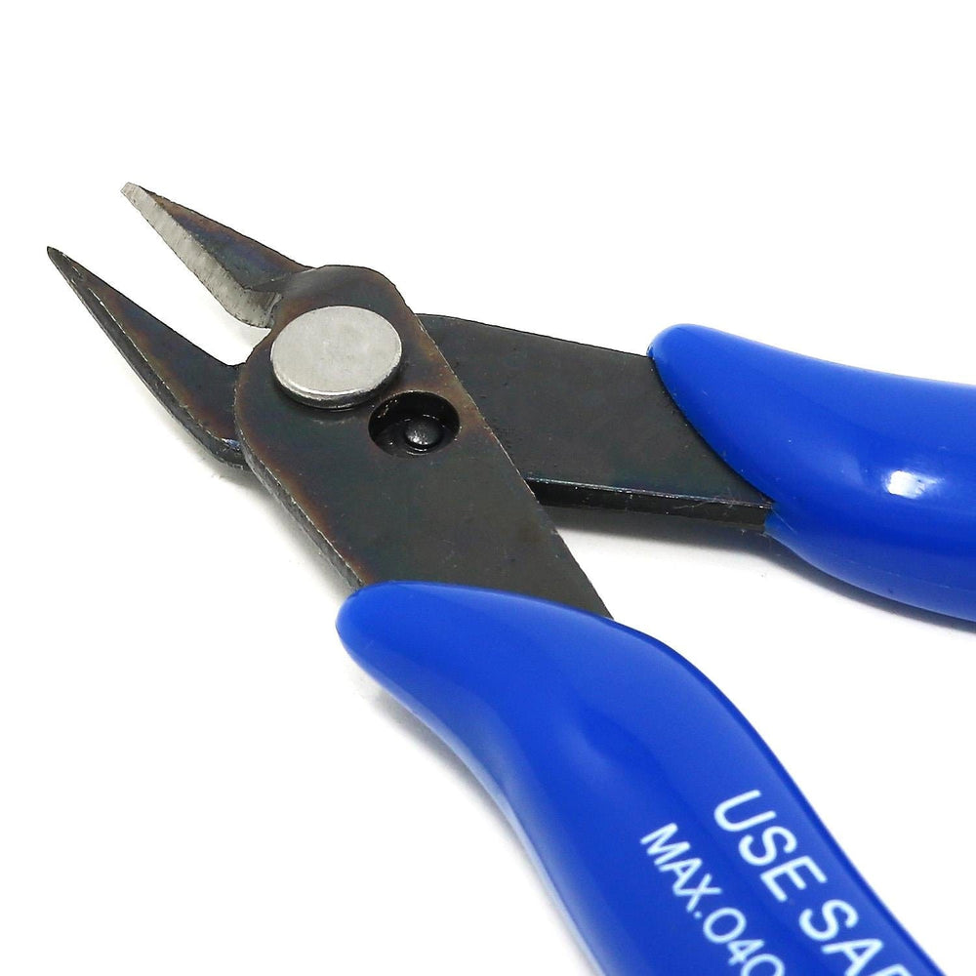
https://thepihut.com/products/precision-diagonal-cutters
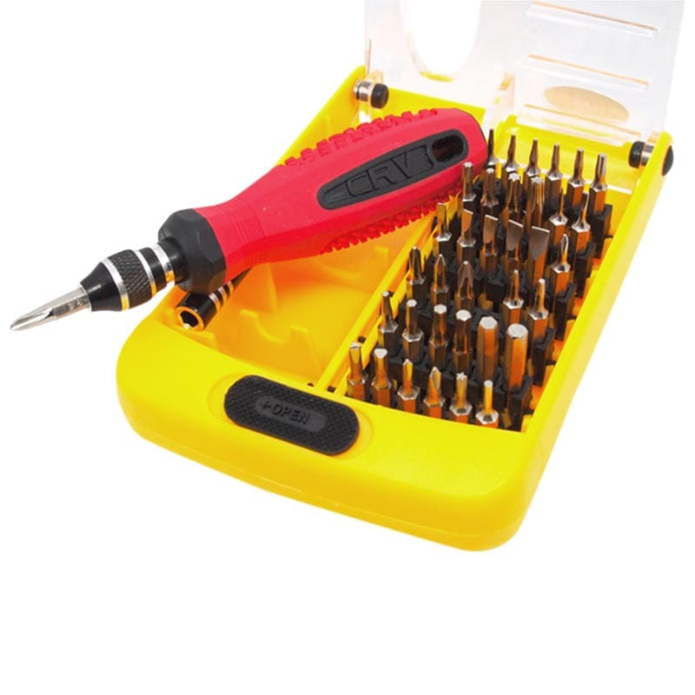https://thepihut.com/products/38-in-1-interchangeable-precise-tool-set
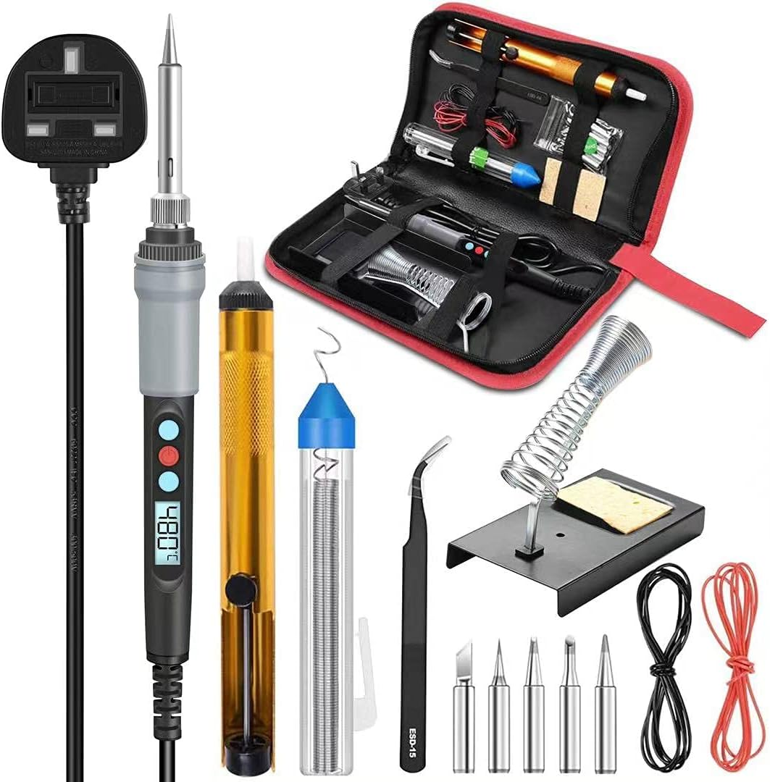
https://amzn.to/4a0yyuT

https://thepihut.com/products/wire-strippers
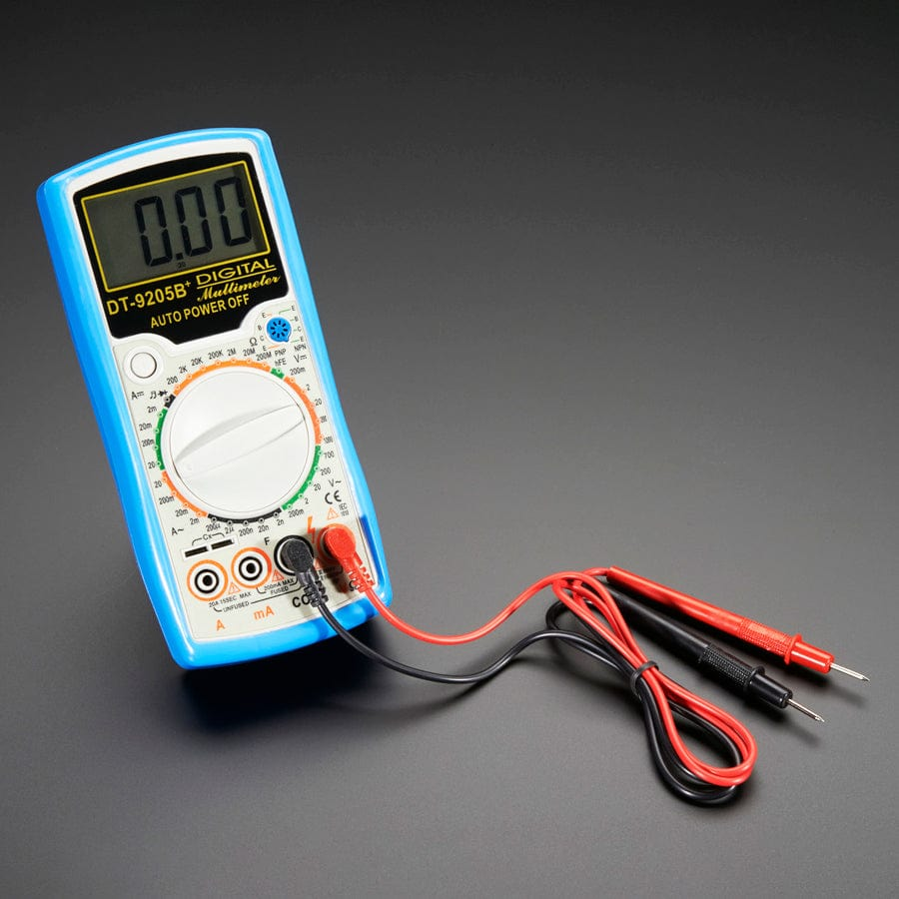
https://thepihut.com/products/digital-multimeter-model-9205b
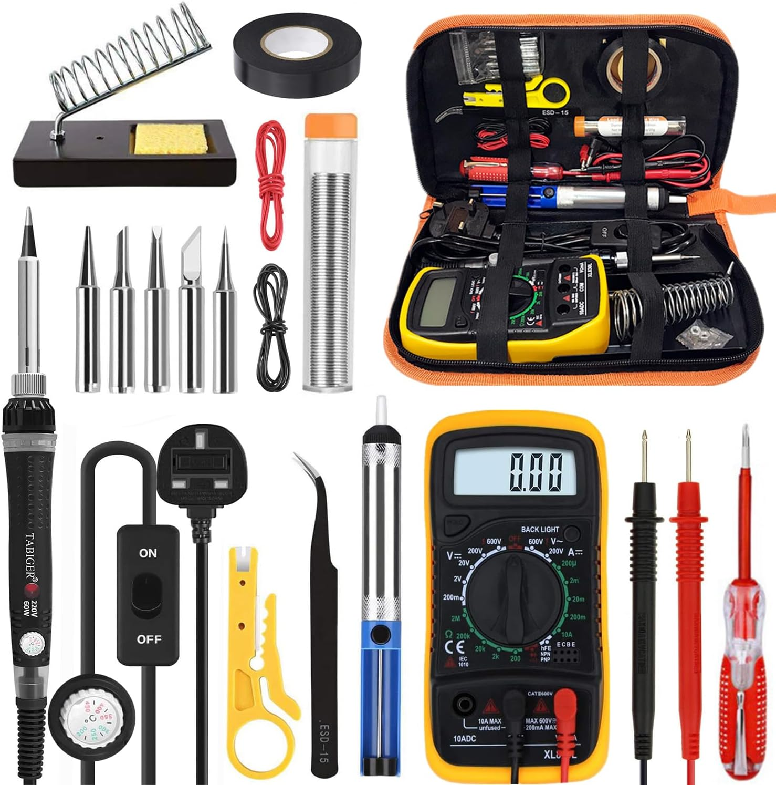

For most projects, you can use any small-diameter solid or stranded hookup wire. Some projects might also require very small wire. A magnifier or magnifying work lamp is recommended for examining the circuit board to check solder connections. Most electronics parts stores have a selection of perforated circuit boards made specially for wiring electronics projects. Many come with small clips for mounting parts. These boards are ideal for building simple circuits. You also will need an electric soldering iron, which you
can buy at a hobby, electronics parts, or hardware store.
The soldering iron in a beginner’s tool kit should be a 15- to 40-watt iron with a fine chisel tip. Use a lead-free solder, like https://amzn.to/4t8N10K. Most of the solder you will need will have a diameter of about 0.8 mm.
You also should have a solder wick (https://amzn.to/4bW02Ve) for desoldering a connection if you make a mistake or want to remove a component.
Use a workbench for your project if you have one. If not, you can use a kitchen table, desk, or sturdy card table. You will need to have good light and ventilation and access to power outlets. You also will need a few small boxes, trays, or jars to hold parts.

Buying Parts
Most electronics parts stores will have the components you will need for your project. If you do a project from scratch, you will have to buy the parts separately. While you also can buy a complete project as a kit, many electronics kits found in retail stores are not soldering kits, and building a project from scratch is challenging and rewarding. Scratch projects can be inexpensive if you can scrounge for most of the parts.
However, a kit has several advantages. All the necessary assembly instructions and parts are supplied, including wire and solder. Special parts, such as printed circuit boards, come with the kit. In addition, fewer tools are required because all necessary holes are pre-drilled. Since the kit has been carefully tested, you know that the finished product will work. A complete kit generally costs less than buying the parts separately. Investigate doing a project both ways before you invest your money.

Basic Electronics Theory
Before you learn about electronic components, let’s look at the theory behind electronics. Controlling electrons is the science of electronics. So, our study of electronics theory begins with the electron.

Atoms and Electrons
To understand electrons, we must learn about the makeup of matter. All matter is composed of atoms, and an atom is composed of three elementary particles: electrons, protons, and neutrons. Negatively charged electrons revolve around the core (the nucleus) of the atom, which is composed of positively charged protons and neutral (not charged) neutrons.
Generally, a negatively charged electron is matched by a positively charged proton. For example, copper has 29 electrons revolving around a nucleus containing 29 protons. A basic law of nature controls electrical charges. This law simply stated is that unlike charges attract and like charges repel. This means a negative charge is drawn to a positive charge but pushes away from another negative charge. This is called electrostatic force. Normally, the positively charged protons hold the negatively charged electrons in place. However, an electron sometimes breaks away from an atom because of an outside force, such as heat, light, magnetic fields, or chemical reactions.
Once freed, electrons can “float” among atoms. These free electrons are what is important in electronics. Devices such as resistors, capacitors, inductors, and transistors are used to control the behaviour of these free electrons.

Conductors and Insulators
Conductors act as a pathway for free electrons. Most metals are good conductors of electrons, so they can be used to “transport” electrons from one place to another. Insulators act as walls or barriers, preventing electrons from flowing where we do not want them to flow. Insulators, for example, are used on most electrical wires to protect us from electrical shock. Copper, silver, and gold are popular conductors because they have many free electrons. As an example of how to make the electrons flow, picture a length of copper wire with one end connected to the positive terminal of a battery and the other end connected to the negative terminal. The positive terminal attracts the negatively charged free electrons of the wire (remember unlike charges attract) while at the same time the negative terminal repels the electrons. The result is a flow of electrons through the wire from the negative to the positive terminal. This flow is called an electric current. An insulator works just the opposite. In some materials, such as plastics and glass, atoms hold their electrons tightly. These materials have very few free electrons. Therefore, if a length of insulator is connected to a battery the same way the copper wire was attached, no measurable current would flow.

Current, Voltage, and Resistance
Here are some basic definitions of terms used in electronics.
- Current is the orderly movement of electrons through a conductor. Current is measured in amperes, or amps, or the rate at which electrons move past a given point. One ampere is the movement of about 6 billion billion electrons past that point in one second.
- Voltage is an electrical pressure that can cause current to flow. Voltage forces current to flow through a wire in much the same way that water pressure forces water to flow through a pipe. This electrical pressure can be caused with magnetism, chemicals, friction, light, or heat. The unit of voltage is the volt.
- The opposition to current flow is resistance. The resistance of a material is mainly determined by how many free electrons it has. If the material doesn’t have many, it will have little or no current flow. The unit of resistance is the ohm. One ohm is the amount of resistance that will allow 1 ampere of current to flow when the applied voltage is 1 volt.

Frequency
Frequency, or cycles per second, uses the term hertz as its unit of measure. The electricity from electrical utilities is 60 Hertz AC and the voltage changes in a sine wave pattern.

Ohm’s Law
Ohm’s law describes the basic relationships between current, voltage, and resistance. The formula for Ohm’s law is:
Voltage (volts) = Current (amperes) × Resistance (ohms)
To determine current, the formula would be:
Current (Amps) = Voltage (volts) ÷ Resistance (ohms)
If you know current and resistance, you can find out the voltage. For example, how much voltage is needed to force 2 amperes of current to flow through 10 ohms of resistance?
Ohm’s law tells us that we need to multiply our 2 amperes. (current) by the 10 ohms (resistance) to arrive at the answer: 20 volts.
If you know voltage and resistance, you can figure out current (Voltage ÷ Resistance). Therefore, how much current will flow in a circuit having 5 ohms of resistance when 15 volts are applied?
15 volts ÷ 5 ohms = 3 amperes
With these formulas, you can solve simple problems involving current, voltage, and resistance.

Power
Another electrical quantity is power. Power is the rate at which work is done. The unit of electrical power is the watt and can be compared to the unit of mechanical power, called horsepower. One horsepower is equal to 746 watts. The formula for power is
Power (watts) = Voltage (volts) × Current (amperes)
When this formula is applied, you can determine the amount of power used by a circuit if you know the voltage and current.
For example, how much power is used by a 120-volt toaster that draws 5 amperes?
120 volts × 5 amperes = 600 watts
The power used by the toaster is 600 watts. This power is used, or dissipated, in the form of heat to toast the bread.

Current Delivery
Electrical signals are classified as either direct current (DC) or alternating current (AC). Direct current signals are at a constant voltage or at a constant polarity where AC signals typically follow a sine wave or other pattern and alternate between positive and negative voltages. If the AC signal follows a specific pattern, the number of times the pattern repeats within one second is the signal’s frequency. The electricity from electrical utilities is 60 Hertz AC and the voltage changes in a sine wave pattern.

Resistance and Resistors
You have learned that when you apply a voltage to the ends of a conductor, it creates a current. Its strength depends on the applied voltage and the resistance of the conductor. The resistance of a conducting material depends on three factors:
- The kind of material
- The length of the material
- The diameter or thickness of the material
Temperature also is a factor in resistance. In most materials, resistance is increased when the temperature rises and decreased if the temperature is colder. In most simple circuits, however, temperature is not critical and is often ignored. The kind of material is probably the most important factor in resistance. Copper, for example, is a good conductor, while iron of a similar size has a higher resistance. Carbon has even a higher resistance than iron.
The longer the conductor, the higher the resistance will be. For instance, if the length of a copper wire is doubled, the resistance will be doubled. As an example, a 60-foot length of copper wire might have a resistance of 1 ohm. A same-sized copper wire that is 120 feet long would have a resistance of 2 ohms.
Size is important, too. A thick conductor will carry more current and offer less resistance than a thin one. Think again of water pipes. A large water pipe will allow more water to flow than a small one. When a current flows through a resistor, a component that limits or opposes the flow of a current, work is being done to move the electrons. This work produces heat and warms the resistor. Heat produced by an electric current is the basis for the operation of many electrical devices and appliances such as heaters, toasters, stoves, and soldering irons. In a lightbulb, an electrical current causes a wire filament to become so hot that it glows to produce light. Only a fraction of the power that comes from the filament produces light.
The rest generates heat, which is why incandescent bulbs are so inefficient. A resistor is designed to have a specific value of resistance, and resistors are available in a wide range of values. Standard power sizes are 1/4-watt, 1/2-watt, 1 watt, and 2 watts. These values indicate the maximum recommended power that the resistor can dissipate. The higher the power rating, the larger the resistor.
Capacitors and Capacitance
A capacitor is a device for storing electrons, or an electrical charge, that can be released later. Imagine two sheets of aluminium foil (conducting plates) that are separated by a sheet of waxed paper (an insulator). If you connect a battery to the two aluminium sheets, electrons will flow from the sheet that is connected to the positive terminal of the battery. Simultaneously, the same number of electrons will flow from the negative terminal of the battery to the other aluminium sheet. The number of electrons that are transferred makes the voltage between the aluminium sheets exactly that of the connected battery. If the battery is removed, the aluminium sheets will remain in their charged state. If there is no leakage through the waxed paper, the sheets will remain charged indefinitely.
Any two conducting plates separated by an insulator make up a capacitor. A capacitor can consist of many conducting plates with insulating separators. Alternate plates would be connected to form interleaved stacks. The higher the voltage, the greater will be the amount of charge that is transferred from one plate to the other. The ratio of charge to voltage is defined as the capacitance of the capacitor. Or you could also say that the “electrical size” of a capacitor is its capacitance, which is the amount of electric charge it can hold. The unit of capacitance is the farad.
However, this unit is too large for most practical capacitors, so capacitors are manufactured to measure millionths of a farad (microfarads) and trillionths of a farad (picofarads, which are micro-microfarads). The insulators that separate conducting plates in a capacitor can be made of several materials, including ceramic materials, mica, certain types of paper, air, and oxide (a compound containing oxygen). A popular capacitor has been the electrolytic capacitor. In this capacitor, the insulator is an extremely thin oxide layer. The leads of electrolytic capacitors are marked positive and negative. These indicate how the capacitor must be connected for proper operation.

Valves (Vacuum Tubes)
Before transistors and integrated circuits became common, electronic equipment often used valves, also called vacuum tubes. Valves could amplify signals and act as switches, helping make early radio, television, radar, and other electronic systems possible. They were generally larger, hotter, more fragile, and less energy-efficient than transistors, so most modern electronics uses semiconductor devices instead. Valves are still found in some specialist equipment and musical-instrument amplifiers.

Semiconductors
The word semiconductor is used to name a wide variety of electronic devices. Made of solid or liquid material, semi-conductors generally can conduct electricity more easily than an insulator, but not as easily as a metal. The semiconductor diode performs the same basic function as the electron-tube diode. It allows current to flow in one direction, but not the other. This diode consists of two different types of silicon crystals. An impurity (some type of substance) can be added to one area of the silicon to control the silicon’s conductivity. The silicon is said to have been “doped” when it has been treated with atoms from an impurity. These atoms combine with the silicon atoms in such a way that electrons float around freely inside the silicon. This type of silicon is called N-type (or negative-type). The N-type silicon is the cathode of the diode.
The other area of silicon also has an added impurity. But the atoms of this impurity combine with the silicon atoms in such a way that there is a shortage of one electron in the bonding. The absence of an electron is called a “hole,” and this hole can grab an electron from a neighbouring atom. Thus, a hole can “float” from atom to atom the same way an electron might. The silicon with the holes is called P-type (positive).
For conventional current to flow through a forward-biased diode, the positive terminal of the supply connects to the anode and the negative terminal connects to the cathode. Electron flow is in the opposite direction. A reverse-biased diode normally allows only a very small leakage current, unless its breakdown rating is exceeded.
The transistor is perhaps the most important invention in the history of electronics so far. A transistor uses the P-type and N-type silicon in much the same way as a diode. However, the transistor has three electrodes, called the emitter, the base, and the collector. The collector is connected to the positive terminal of the battery, and the emitter is connected to the negative terminal. Electrons will try to flow from the emitter to the collector. However, a thin layer (the base) separates these two elements. If the base is negative, it repels the free electrons in the emitter. In this case, no current can flow from the emitter to the collector.
If the base is positive, electrons can flow into the base from the emitter. Some of the electrons will flow into the positive base lead. But because the base is very thin, most of the electrons travel through the base to the collector. Thus, if the base is made more positive, more electrons will flow. Conversely, making the base less positive will reduce the current flow. You can see then that a small voltage on the base will control the amount of current through the transistor. For this reason, the transistor can be used as an amplifier in much the same way as a vacuum tube.
Notice the symbol in the illustration used to represent the NPN transistor. Another type of transistor is called the PNP transistor. Its structure and schematic symbol are shown in the following illustration. This transistor requires opposite polarity voltages for proper operation.
NPN and PNP transistors are called bipolar transistors, and they are the most popular types used.

Field Effect Transistor
The field effect transistor uses a single N-channel or P-channel with an insulated metal plate used to control current flow. Current enters the channel at the source lead and flows toward the drain lead at the other end of the channel. The voltage applied to the insulated plate, known as the gate, limits the current flow through the channel from source to drain. The most used FET is the metal-oxide semiconductor FET or MOSFET. An N-channel MOSFET will not conduct current if there is no voltage difference source to gate and allow current flow when a higher voltage is applied to the gate (voltage difference with respect to the source pin). A P-channel MOSFET will conduct current if there is no voltage difference source to gate and allow current flow when a lower voltage is applied to the gate (voltage difference with respect to the source pin).
Complementary MOS or CMOS technologies use one P-channel MOSFET and one N-channel MOSFET connected such that the P-channel source pin connects to the circuit higher voltage (typically power supply) and connects the N-channel source to the lower voltage supply (typically 0-volt or ground). The drain of the two MOSFETs are connected and is the circuit output. The gates are tied together. When the gates are connected to a low voltage (ground), the source to gate voltage of the N-channel is 0 volts so the channel transistor is “off” while the gate to source voltage of the P-channel FET is the “hi” voltage, so that transistor is “on” meaning the output voltage is connected to the power supply or high (for a low input). Conversely, if the two gates are tied to the higher voltage, the N-channel gate to source is now high, so it is “on” while the P-channel transistor gate to source is voltage is low, so it is “off.”

Integrated Circuits
An integrated circuit (IC) is a complete circuit in a single package. Transistors, resistors, diodes, and capacitors can be formed in a single chip of silicon, a semiconductor. One chip can contain thousands or even millions of electronic components. Integrated circuits have revolutionized many fields, including communications, information handling, and computing. They have reduced the size of devices, while providing faster speeds and increased reliability. The individual components of ICs are extremely small and are assembled to a pattern that has been planned. A chip might look flat, but it has several layers for circuits. Switches control the electrical current through the chip. The switches manipulate the binary code (discussed below) with “on” and “off” switches. The binary code is at the core of how a computer operates.
Chips come in many different sizes, with millions of transistors being able to fit on chips the size of a postage stamp. Two basic types of IC are called linear and digital. Linear circuits include amplifiers, oscillators, regulators, and other circuits used in TV sets, audio amplifiers, radios, and hearing aids. Digital circuits include memories and arithmetic circuits and counters in watches, calculators, computers, and video games.

Microprocessors
The microprocessor is a type of ultra-large IC. By 1971, the technique of making ICs had progressed to the point where enough computing power could be put on a single IC to form a tiny, primitive computer, or calculator. The first microprocessor was born. Today, microprocessors can incorporate more than a billion transistors, plus components such as resistors, capacitors, diodes, and wires. The microprocessor accepts input data, modifies that data in some way, and produces an appropriate output. The earliest application of the microprocessor was the calculator. A calculator accepts numbers that the user enters on a keyboard, performs a mathematical operation on those numbers that the user desires, and then sends the result to a display.
Today’s microprocessors function as the central processing unit (CPU) of computers. They also are used in many electronics systems such as cameras, printers, planes, and automobiles. The microprocessor in an automobile, for instance, examines inputs from several sensors, makes decisions based on those inputs, and adjusts such things as the mixture of air and fuel and the timing of ignition firing. The microprocessor’s most important aspect is that it can be programmed to perform an almost limitless number of applications.

Printed Circuit Boards
A printed circuit board (PCB) consists of a sheet of some type of insulator, a composite material classified as FR-4 made of woven fiberglass cloth with an epoxy resin binder. The FR-4 material is an insulator with copper traces printed or etched onto the FR-4 surface. The copper traces are implementations of the wire lines of the schematic drawing. Parts of traces may need to be routed from one side (layer) to the other side (layer). To connect the traces, feed-through holes are added to the circuit board. Feed-through holes are drilled through the printed circuit board then filled with solder. The solder connects the copper of the top, bottom, and optional intermediate layers. Feedthrough hole’s solder is done during the fabrication of the circuit board.
Optionally, feed-through holes can be used to hold component leads. The feed through has a hole drilled through the solder for the component lead. The drilled hole is done during fabrication of the printed circuit board. The completed printed circuit board is now ready for insertion of the components drawn in the schematic.
A feed-through hole used for a component lead must be larger to allow room for the component lead diameter plus some insertion clearance of the lead into the hole. If no component lead is being inserted in the hole, the diameter of the feed-through hole can be much smaller and require less printed circuit board space. Later, during the assembly process, a component lead is inserted into the hole and the hole and lead must be soldered together to make solid electrical contact. Several layers of traces, separated by FR-4 sheets may be sandwiched together for more complex electronic designs with feed-through holes connecting the traces as needed.

Through-Hole Technology
The technology used for placing component leads in holes drilled through the printed circuit board reached a practical limit when integrated circuits got over about 40 pins. A feed-through hole with space for the lead and the insertion tolerance meant that, based on PCB fabrication technologies at the time, integrated circuit leads needed to be about 0.100" apart. Various techniques were tried with larger IC packages including longer packages, the IC pins in a grid pattern and others. There was not a viable solution to reach what would eventually be today’s package pin counts.

Surface-Mount Technology
By removing the component pin from going through the feed-through hole, the feed-through could be much smaller and moved away from the component. The component pins could be replaced with a square pad on the component, and the printed circuit board would have a matching pad on the “out-side” copper layer. Without the constraint of the feed-through hole with drilled lead space, component pins could be placed much closer together or more pins could be placed around the former through hole package sizes. This change led to the very high pin count packages required for today’s integrated circuits, such as the processor of your home computer.

Schematic Diagrams
The illustrations in the previous section didn’t show you a picture of a real diode or transistor. Instead, they showed you a kind of illustrated outline, called a schematic diagram. These diagrams are a simple way of showing how electronic components are connected. In a schematic, symbols stand for the different electronic components. The schematic diagram illustrated here is for a code-practice oscillator, used to practice Morse code. The corresponding pictorial representation shows how the components look. In the schematic, a different type of symbol represents each type of component:
long and short lines represent the battery; a zigzag line stands for a resistor. In this section, you will learn these symbols so that you can understand schematic diagrams.
To start, compare the schematic diagram with the pictorial and match each symbol in the schematic with its equivalent component in the pictorial. Also match each line in the schematic with the appropriate wire in the pictorial. Notice where two lines cross in the schematic. If the wires are to be connected, a dot shows at the crossing on the schematic. If there is no dot, the two wires bypass each other and are not connected.
When you draw your schematic for requirement 2, you will need a sharp pencil, paper, and a ruler or straight edge for drawing straight lines. A compass might be helpful for drawing circles. If you have a computer with a drawing program, you might use that to draw a schematic. There are also several freely available schematic capture tools.

Component Types
Before we look at the most common types of electronics components, as well as the schematic symbol and a pictorial of each one, let’s define and review some basic terms (also see the Basic Electronics Theory section):
- Electricity is a property that electrons have that causes them to behave in certain predictable ways.
- Electrical charge is a quantity of electricity.
- The electron is a tiny particle that has a negative electrical charge.
- Current is defined as the flow of electrons.
- Voltage is the pressure that causes current to flow.
- Resistance is the opposition to current flow.
- Direct current (DC) is current that always flows in the same direction.
- Alternating current (AC) is a current that reverses its direction of flow many times each second.
- Frequency is the number of times that a repeat its pattern in one second.

Passive Components

Fixed Resistor
Each resistor has a specific amount of resistance. A resistor is like a nozzle on a water hose. For a given water pressure, the nozzle controls the amount of water that is allowed out of the hose. Similarly, for a given voltage, a resistor controls the flow of electrical current.
Most resistors are made of a carbon compound. Resistors used for high currents often are made from special wire that is wound on an insulating form. The type of compound or wire used determines how much electrical current can flow for a given voltage. The value of a resistor is given in ohms. The symbol for the ohm is the Greek capital letter omega (Ω). Thus, 1Ω designates the resistance of 1 ohm. A 1kΩ resistor has a resistance of 1 kilohm, or 1,000 ohms. A 1MΩ resistor has a resistance of 1 megohm, or 1 million ohms.
The illustration below shows a variety of fixed resistors and a cross-section of a fixed resistor. The values of fixed resistors cannot be changed.
Older types of fixed resistors have bands of colour that allow you to determine their resistance value. (See “The Colour Code of Resistors” section on page 40.) The cross-section of this fixed resistor shows the inside, which is made of carbon.
Note the schematic symbol for a fixed resistor.

Variable Resistor
The resistance of variable resistors can be adjusted. Rheostats are two-leaded devices that vary in resistance from 0 to the rated resistance value. Three leaded variable resistors, known as potentiometers (pots), have a fixed resistance between leads 1 and 3, and have a resistance on lead 2 proportional to the amount of rotation on the adjustment arm. These variable resistors can be used in appliances that need their currents adjusted or when the resistance needs to be varied, such as with lights that can be dimmed.

Capacitor
A capacitor is a storage element for electrical charge, like a bottle that stores a liquid. The basic unit of capacitance is the farad (F). Practical capacitors have capacitance values in microfarads (µF). The physical size of a capacitor depends on its voltage rating and its capacitance value. The higher the voltage rating and the larger the capacitance value, the larger the capacitor must be.

Inductor
An inductor is a coil of wire usually wrapped around some type of metal or hollow core material and is used to smooth out variations in the current flow. When current is applied to the coil, a magnetic field is established around the core. When the current flow stops, the magnetic field begins to collapse and in doing so induces current back into the wire until the field has collapsed. The magnetic field tends to collapse at a rate that maintains the original current in the wire. Single coil configurations are generally called a choke whereas two or more coils can be configured either as a choke to filter current changes or as a transformer for changing voltage and current values.

Transformer
A transformer consists of two or more coils each with multiple turns of wire around the magnetic core. The primary coil is the coil where power is applied to the transformer, and the other coils are referred to as secondary coil(s). The transformer uses the magnetic field established by current flow in the primary coil to induce a current in the secondary coil(s). The ratio of turns from the primary to a secondary coil determines how much the incoming voltage is multiplied on the secondary side and how much the secondary current is divided by the primary current in the secondary. Because transformers operate on changing magnetic fields caused by changing current, transformers do not operate on direct current (DC) currents.

Semiconductor Devices
Semiconductor devices are typically made of silicon-based material. Diodes and transistors are two common semiconductor component types. Semiconductors come in various package sizes based on the amount of power they must dissipate in rated operation.

Diodes
Diodes operate as check valves, passing current in one direction but not the other. A diode’s most common application is in power supplies. It changes alternating current (AC) into direct current (DC).

Transistors
Transistors are solid-state devices used for controlling current. A very small input current controls a much larger output current. For example, the small current from a microphone can control a much larger current that drives a loudspeaker. This is the idea behind the audio amplifiers used in public address systems.

Integrated Circuits (ICs)
Complex circuits are available in integrated circuit (IC) form at inexpensive prices. The IC, which typically consumes little power, is reliable, cheap, and small. Because devices using ICs can be improved and made cheaper, the IC has replaced traditional components in many applications. As shown here, ICs come in several types of packages. The dual in-line package (DIP) is the most popular style for most hobby applications.
Schematic symbols for ICs are typically very function specific.

Electromechanical Components

Microphone:
A microphone changes sounds into electrical impulses. Either a thin, flexible disk (a diaphragm) or a crystal in the mike vibrates whenever sound strikes it. The vibrations are changed into small electrical signals. These signals typically need to be amplified before they are usable.

Speaker
A speaker then converts the electrical impulses back into sounds. An electromagnet moves a speaker cone based on the incoming audio signal. The speaker cone moves the air around and it which causes the audio sound to spread across the space and recreating the original sound.

Switches
Switches are an important part of almost all electronic equipment. They come in a wide variety of shapes, sizes, and functions. Switches are categorized by the number of circuits they switch (single, double, triple, etc.) and then by the number of switch position contacts. A switch may have an output contact for each position of the switch. The switch will typically have a default position. A circuit that makes contact in that position is called a Normally Closed (NC) contact or in drawing below from terminal A to C. If the switch is moved out of default position, and contacts an electrical terminal, that position is called Normally Open (NO) and is shown as connections A to B in drawings below).
The simplest is the single-pole, single-throw type. When closed, this switch completes a circuit, allowing an electric current to flow. When it is open, the circuit is broken, and the current does not flow. The on-off switches on most electronic devices are of this type (above left).
A single-pole, double-throw switch has a contact arm that can be set in either of two positions. In the example shown here, terminal A can be connected to either terminal B or terminal C. The dashed line between the switches shows the mechanical connection (above centre).
A double-pole, double-throw switch can simultaneously switch two wires from one circuit to another. It can be thought of as two single-pole, double-throw switches that operate together (above right).
A rotary or selector switch has one or more arms (poles) that can be set to various positions. A single pole 10-position switch is shown below. Notice that the terminal at the very bottom connects the signal to the rotatable arm.

Relays
A relay is a magnetically operated switch. It has a wire coil wrapped around an iron core forming an electromagnet. When current flows through the coil, a magnetic field develops. The magnetic field attracts a movable part called an armature, which moves all relay switch poles from normally Closed (magnet off) to Normally Open (magnet energized).
A relatively small current can cause the switch contacts to close, but the contacts can handle a much heavier current. The relay allows a small current to switch higher current(s) on or off. By using several contact sets (single, double, triple or more poles and single or double throw). A multi-pole relay allows a single control (coil) current to control several different currents simultaneously.

Chemical Components

Batteries
Batteries are made from several types of materials for different uses. Alkaline, lithium, and mercury batteries are used when long life is desired. Nickel-cadmium batteries give shorter service but can be recharged. The nickel–metal hydride battery is replacing the nickel-cadmium battery because it doesn’t suffer the memory effect (that is, not allowing a partially charged battery to fully recharge before use). Lithium-Ion type batteries have replaced many of the older battery types. Zinc-carbon also is used in many inexpensive dry-cell batteries. Most electronic circuits and products operate at low supply voltages and have low power requirements. These devices are often driven from small batteries or DC voltage sources. Depending on the type of product, a coin battery, one, two or four flashlight batteries are often adequate for relatively long service.
Ordinary flashlight dry cells produce approximately 1.5 volts. Four 1.5-volt cells connected in a series can provide 6 volts. Single 9-volt batteries also are used.

Photocells
A photoelectrical cell changes one or more of its characteristics when exposed to light. It is popularly called the electric eye, which controls operations such as traffic lights, door openers, and devices that activate lights at dusk and turn them off at dawn. One type of photoelectric cell is called a photoconductive cell. Another name for this type of cell is the light-dependent resistor (LDR). This special resistor has a small window so that light can strike the resistance material. Generally, such a cell has a high resistance when in darkness. Another type is called a photovoltaic cell. This is the familiar “solar cell” that is used to power electronic equipment on spacecraft. It produces a low voltage across its terminals when exposed to light, especially sunlight, thus converting light energy into electrical energy.

Other Component Types
There are many other types of components used in electronics, but these are the more common components that a hobbyist is likely to use.

The Colour Code of Resistors
The value of a resistor is specified in ohms and is indicated by coloured bands around one end of the resistor. The electronics industry devised this system because small, printed numbers would be too hard to read or might be concealed by the position of the resistor.
Most resistors have four bands, with the first three (counting from the end of the resistor) indicating the value in ohms. The fourth, which is either silver or gold, indicates the tolerance (discussed below). colours used for the bands are used in place of numbers. To determine the resistance value in ohms, examine the colour bands starting with the one closest to the end of the resistor.
Suppose a resistor has a brown, a black, and then a brown band. The code chart shown here tells you that brown represents the number 1. The second black band represents the number 0. The third band tells you how many zeroes to add to the first two numbers. In the example, the band is brown, so you add one zero. Therefore, the value of this resistor is 1-0-0, or 100 ohms.
Now try the example for the resistor shown here, which has a red band first, then a yellow band, and then an orange band. The red band means that the first number is 2. The yellow band corresponds to the number 4. The orange band tells us to add three zeroes. Thus, the value is 2-4-000, which translates to 24,000 ohms, or 24 kilohms (kΩ).
Most surface mount components are too small for colour bands, so the colour bands are converted back to digits and printed onto the top of the resistor as 243 for 24,000 ohms, or 24 kilohms (kΩ).
See the Resistor Colour Code Wheel

Soldering
Before you begin working with a circuit, read and study this chapter on soldering. Anyone working in electronics must know how to solder well, and safely. It takes practice, but once you learn, you will be able to properly assemble an electronics project. In all electronics work, the wiring connections must be secure. A loose connection in a radio, for example, could result in noise, scratching sounds, or no sounds at all. Poor connections in a TV could disrupt the sound and picture. And beyond just a radio and a TV in someone’s home, the safe operation of airplanes and the lives of astronauts in flight depend on secure electronics connections.
Soldering is not just gluing metals together. Done correctly, it creates a reliable electrical and mechanical connection between clean metal surfaces. Use the solder alloy and flux recommended for the equipment and project. Lead-free solder is preferred for beginner activities unless a Leader has approved another type.
There is a section near the rear of this document called Soldering is Easy on page 57.

How to Desolder
In case you accidentally make a wrong connection or must move a component that has been placed incorrectly, you should learn how to desolder connections. Take care when desoldering to avoid breaking or destroying good parts. The leads on components such as resistors or transistors and the lugs on other parts might sometimes break off when desoldering a good, tight joint. To avoid heat damage, use as much care in desoldering delicate parts as you do in soldering them.
There are two ways to desolder. The first and usually easiest way is to use a metal wick or braid on a small dispenser reel to remove the melted solder. This braid is available at most electronics parts’ stores. Place the braid against the joint that you want to desolder. Use your heated soldering iron to gently press the braid against the joint. As the solder melts, it is pulled into the braid. Don’t let the joint cool while the braid is resting against the joint. By repeating this process, you can remove virtually all the solder from the joint. Then reheat the joint and lift off the component leads.
The second method involves using a desoldering pump, or a vacuum device, to suck up the molten solder. Most electronics parts stores have these devices. Follow the manufacturer’s instructions for the pump you are using, but here are some general guidelines. Use your soldering iron to heat the joint you want to desolder until the solder melts.
Then push down on the top of the pump to remove the air inside. Next, quickly place the tip of the pump on the melted solder you want to remove and press the button on the side. This will cause the pump’s plunger to rise rapidly and create a vacuum inside. The rush of air at the tip of the pump will pull the melted solder in. Repeat until you have removed most of the molten solder. Then reheat the joint and gently pry off the wires. Experiment with and practice your soldering techniques to fulfil requirement 3 before you begin working on your circuit. Use pieces of wire or some old components and wire. Practice until you can solder joints that are smooth, shiny, and tight. Then practice desoldering some of the connections until you are satisfied that you can do them quickly and without breaking wires or lugs.

Soldering Printed Circuit Boards
Most electronic devices use one or more printed circuit (PC) boards. A PC board is made of a nonconducting material, such as a thin sheet of fiberglass or phenolic resin (plastic) that has a pattern of foil conductors “printed” on it and has predrilled holes designed to hold components. You insert component leads into the holes and solder the leads to the foil pattern. This method of assembly is widely used, and you probably will use it if you choose to work with an electronics kit. Printed circuit boards make assembly easier. First, insert component leads through the correct holes in the board. Mount the parts tightly against the circuit board unless otherwise directed. Insert a lead and then bend it slightly outward to hold the part in place. Then follow these steps.
- Touch the tip of your soldering iron to both the component lead and the foil until they are uniformly hot enough to melt the solder.
- Apply a small amount of solder to both the tip and the connection.
- Remove the iron and let the solder set before moving the wire or the board. The finished connection, as you have learned, should be smooth and shiny.
- Finally, clip off the excess wire length.
If a solder bridge forms, switch off the power and remove it with solder wick or a suitable desoldering pump. Do not wipe molten solder away with a cloth or touch it while it is hot. Inspect the board for damage before testing the circuit again.

Control Devices
An important application of electronics is the control of certain operations with the use of control devices. For example, control devices can make lights go on at certain times or open doors automatically. To satisfy requirement 4, you will build a working electronic circuit. You may choose to build a control device.

Building a Control Device from Scratch
You can build a control project from a kit, but you may want to build a project from scratch. The one shown is easy to build and fun to use. It is a control circuit that uses light to control an audible alarm. This is a popular type of control circuit. It could be used to detect when the sun is shining so you can turn out your lights and save power.
The circuit is constructed on the single piece of 3-by-4-inch perforated board. While the exact size is not critical, a board that is too big is better than one that is too small. The holes in the board need to be 1/10 inch apart. This is necessary so that the pins of the op amp will fit.
Many types of boards are available. The board used (and shown in the photographs) for this project has foil patterns designed especially for integrated circuits, which makes the project easier. To use this type of board, insert components through the board from the top and solder to the foil patterns on the bottom of the board. You make connections from one component to the next by using short wires called jumpers.

Procedure
To build this circuit, follow these steps.
Step 1—Gather the parts. You may be able to buy parts at an electronics supply store, but more easily today you can purchase electronic components online (see the resources section at the back of this book). It’s a good idea to make sure you can find all the parts before you buy any of them. This circuit will work with a wide variety of parts.
Step 2—Lay out the circuit board. Before you begin, decide where each component will go on the board. The illustration here shows a suggested layout. Lay the components on the board and trace the outline of each to make sure everything will fit properly.
Step 3—Drill the holes. You must drill several holes (see the illustration for the pattern) in the circuit board before mounting any components. The four holes at the outer corners are for the four standoffs, or legs, that will hold the circuit board. It is recommended that you buy a board that has these four holes already drilled. This will leave you with only three holes to drill. The first is the small hole for the battery holder. Make this hole slightly larger than the screw that holds the battery holder to the board. Two larger holes are required for the potentiometer and the switch. In each case, make the hole slightly larger than the part that is to be inserted through it. Drill the holes carefully so you don’t damage the perforated board.
Step 4—Mount the IC. Attach the 741 op-amp first. It must be mounted so that its pins are attached to foil patterns that allow additional components to be attached. Insert the IC in the top of the board.
Identify pin 1 of the 741 Op amp IC as illustrated on the top of the next page. Mark pin 1 on the board with a pencil so that it is easier to identify each of the pins as you solder components to them.
Step 5—Mount the LDR. Insert the leads of the light-dependent resistor into the board at the location shown and solder the leads to the foil. Don’t worry about which lead is which. The LDR can be turned either way.
Step 6—Mount R2, R3, and R4. Insert the leads of the resistors at the locations shown. Bend the leads over so that you can insert them through the board and solder them to the bottom side. Don’t worry about which lead is which. The resistors can be turned either way.
Step 7—Mount the transistor.
Insert the transistor (Q1) into the board, carefully observing the emitter, base, and collector connections. The drawing illustrating the 2N3053 transistor seen at the bottom of the page shows how to identify the three elements.
Step 8—Mount the buzzer. Insert the buzzer (PB) through the board. Note that the minus (–) and plus (+) sides must be connected as shown in the schematic.
Step 9—Mount the switch. First remove the retaining nut. Mount the switch by pushing it through from the bottom of the board. Attach it to the board with the retaining nut. Cut two lengths of wire, each about 3 inches long. Remove 1/4 inch of the insulation from each end of the wire. Turn the board upside down and connect the centre switch post to a foil pattern using a prepared wire and one of the side of the switch posts to another foil pattern using the other wire.
Step 10—Mount the potentiometer. Remove the retaining nut. Mount the potentiometer (R1) by pushing it through from the bottom of the board. Attach it to the board with the retaining nut. Cut three lengths of wire, each about 3 inches long. Remove 1/4 inch of insulation from each end of the wire. Turn the board upside down and connect the potentiometer lugs to the foil patterns by using the three prepared wires as seen in the top view shown here.
Step 11—Mount the battery holder.
Step 12—Mount the battery clip. Strip 1/4 inch of insulation from the ends of the battery clip’s black and red leads. Solder the black and red leads to the board. Do not connect the battery yet.
Step 13—Interconnect each of the components using small jumper wires, being sure each wire is electrically connected between the correct components. A good way to do this is to refer to the schematic and colour each line on the schematic as you connect that jumper wire on the board. Cut each wire to the length needed and remove 1/4 inch of insulation from each end of the wire. Insert the jumper from the top of the board and solder to the foil on the bottom.
Step 14—Check all wiring. Before you apply power, recheck all wiring as described in the soldering section. Make certain that all components are interconnected properly. Check the pins of the op amp to make certain that you have the pin numbers right. Also recheck the placement of the transistor (Q1).
Step 15—Apply power. Attach the battery clip to the battery. If the buzzer sounds, flip the on-off switch to the opposite position. Place the battery in the holder.
Step 16—Coarse-adjust R1. Flip the on-off switch to the “on” position. If the buzzer does not sound, adjust the potentiometer until you hear a sound from the buzzer. If you cannot make the buzzer sound by turning the potentiometer, flip the switch in the “off” position and adjust the potentiometer until the buzzer sounds. If the buzzer will not sound in either switch position, then immediately disconnect the battery and recheck all wiring. Correct the problem by rewiring as necessary. Repeat the process until you hear a tone from the buzzer.
Step 17—Fine-adjust R1. Once you get a sound from the buzzer, cover the LDR with a finger to block light from the device. With the LDR covered, back off the setting of the potentiometer just to the point where the buzzer no longer sounds. The buzzer should now sound when the LDR is uncovered but stop buzzing when the LDR is covered. The circuit is detecting the presence of light and responding by sounding the buzzer.

Circuit Operation
To understand how the circuit works, refer to the schematic diagram shown on the previous page. Start at the buzzer (PB) and work backward. The buzzer will sound when current flows through it. Transistor Q1 controls the current through the buzzer. When Q1 conducts, current flows through Q1 and the buzzer, creating the sound. In turn, the 741 op amp controls Q1. The 741 (IC1) is an integrated circuit that contains dozens of transistors connected as a very high-gain amplifier. This means that it can amplify extremely tiny differences in the voltages applied to the two input terminals (pins 2 and 3).
The resistance of the light-dependent resistor (LDR) determines the voltage on pin 3 of the op amp. If no light strikes the LDR, the resistance across the LDR is high, which causes the voltage at pin 3 of the op amp to be low. When light hits the LDR, its resistance falls and the voltage on pin 3 of the op amp increases.
Before using the circuit, in steps 16 and 17, you adjusted the setting of R1. Moving the arm of R1 changes the voltage at pin 2 of the op amp. With the LDR shielded from light, you set R1 just below the point at which the buzzer is activated. When R1 is properly set, the voltage at pin 3 is slightly lower than the voltage at pin 2. The op amp amplifies this tiny difference in voltage and produces a very low voltage at its output. This low output voltage holds Q1 cut off so that no current can flow through the buzzer.
When light hits the LDR, as was noted, its resistance drops. This increases the voltage at pin 3 of the op amp. The op amp amplifies this difference, producing a high voltage at its output. This turns Q1 on, forcing current through the buzzer and sounding the alarm.

Digital Electronics
Since the use of transistors began in 1948, the field of electronics has undergone a revolution that continues to allow for the introduction of a vast array of new devices. The development of digital electronic components has revolutionized fields such as computing, communications, and information handling. Such components have replaced many traditional circuits and components.
Possibly the best example of this revolution is the personal computer and related products. Other examples are digital watches, digital thermometers, hand-held computers and games, complex calculators, electronic games, televisions, and digitally recorded music and videos.

Binary Number System
To understand digital electronics, you must first learn the binary number system, which is used in digital equipment.
The decimal system of numbering uses 10 different digits: 0, 1, 2, 3, 4, 5, 6, 7, 8, and 9. This number system is suitable for people but is too complex to be used by electronic circuits. Digital logic is a simple process that can make only two decisions: true or false. So, the binary number system has only two digits: 0 and 1. Thus, “true” can be presented by 1 and “false” by 0.
With only two digits, how are numbers larger than 1 represented? The answer is the same way numbers greater than 9 are represented in the decimal system. In the decimal system, the highest single-digit number is 9. We represent numbers greater than this by using two or more digits in combination. That is, 10 is represented by using the digits 1 and 0 together.
In the binary system, the highest single-digit number is 1. To represent numbers greater than this, we again use two or more digits in combination. The number 2 cannot be represented by the symbol “2” because this digit is not used in the binary system. Instead, the digits 1 and 0 must be used together, to form 10. Therefore, in the binary system, 10 represents the number 2 and not the number “ten.” The number 3 is represented by the next larger two-digit number of 11.
Now, how do we represent the number 4 in binary? Since we no longer have two-digit possibilities, we must use a three-digit number. The lowest three-digit number is 100. In the decimal system, this means “one hundred.” In the binary system, 100 means “four.”
Here is a chart showing decimal numbers up to 17 and how to represent them using the binary system. Study this table to help you understand the binary sequence. Then try to continue the list to 32 (decimal), or 100000 (binary).

Woggle
This is derived from the Scouts Queensland eWoggle, and follows the design principles laid out in the document “Circuit design principles for Scout electronics projects for JOTA/JOTI” by Michael Gross of Cobargo Venturers (https://cobargoscouts.org.au/jota-joti-electronics.html), I have also combined the functionality of the eWoggle with the Franzininho DIY (https://docs.franzininho.com.br/docs/franzininho-diy/sobre) Arduino like capabilities allowing the scouts to upload new firmware after they have assembled their woggles.

Woggle KiCad files
The woggle was designed in KiCad,

Soldering is Easy
The following graphical guide is by Mitch Altman, Andie Nordgren and Jeff Keyzer. And is available in other languages and to download at https://mightyohm.com/soldercomic
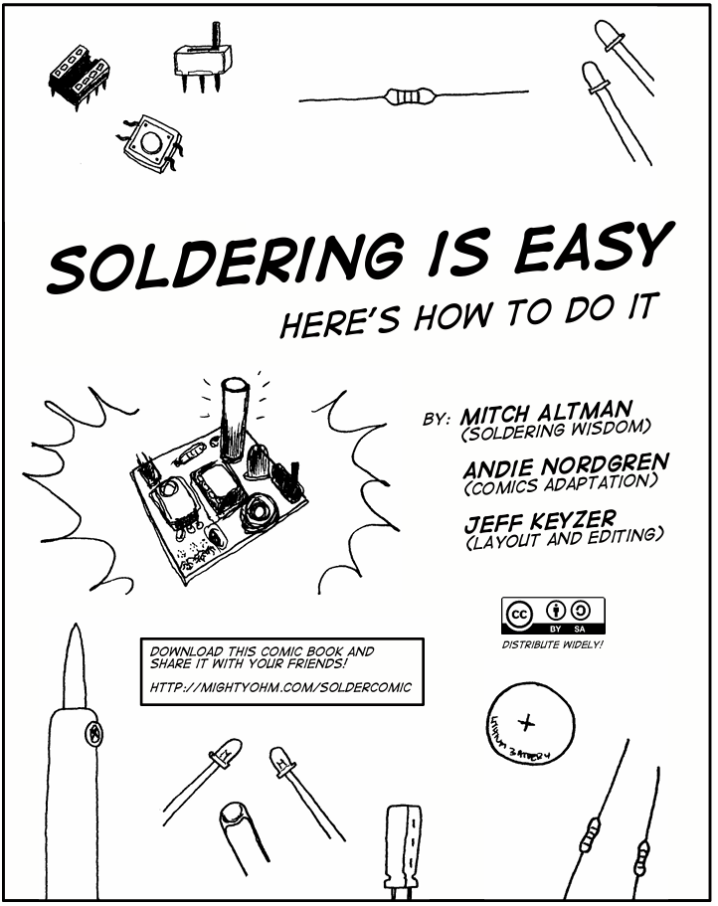
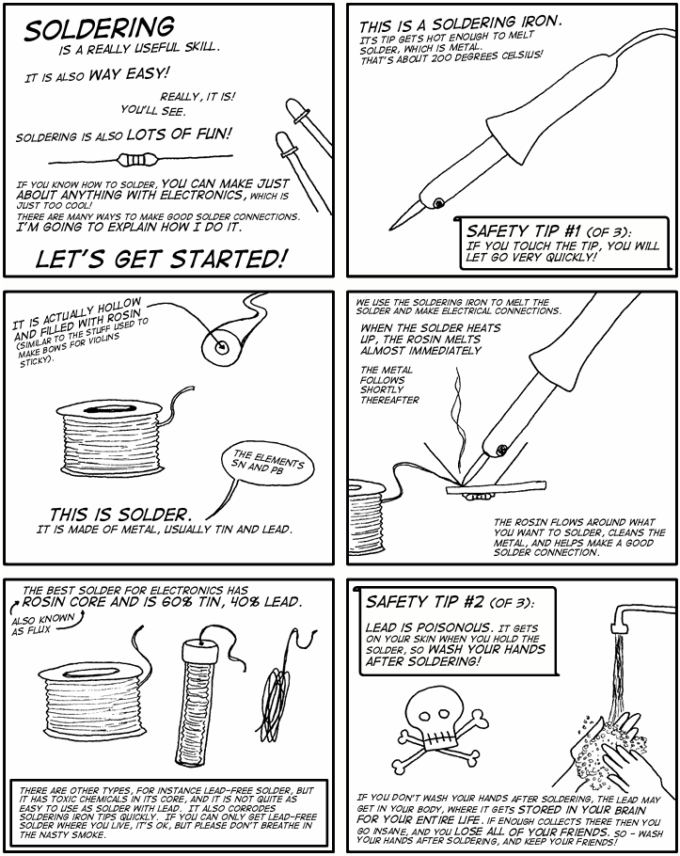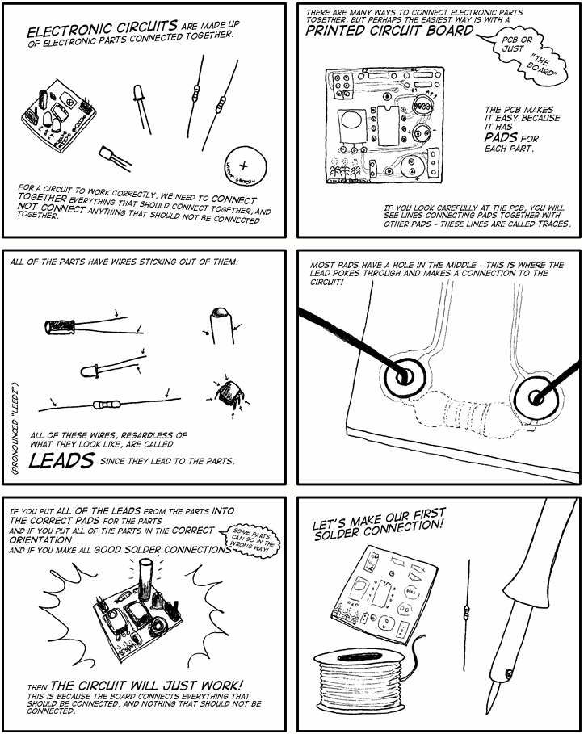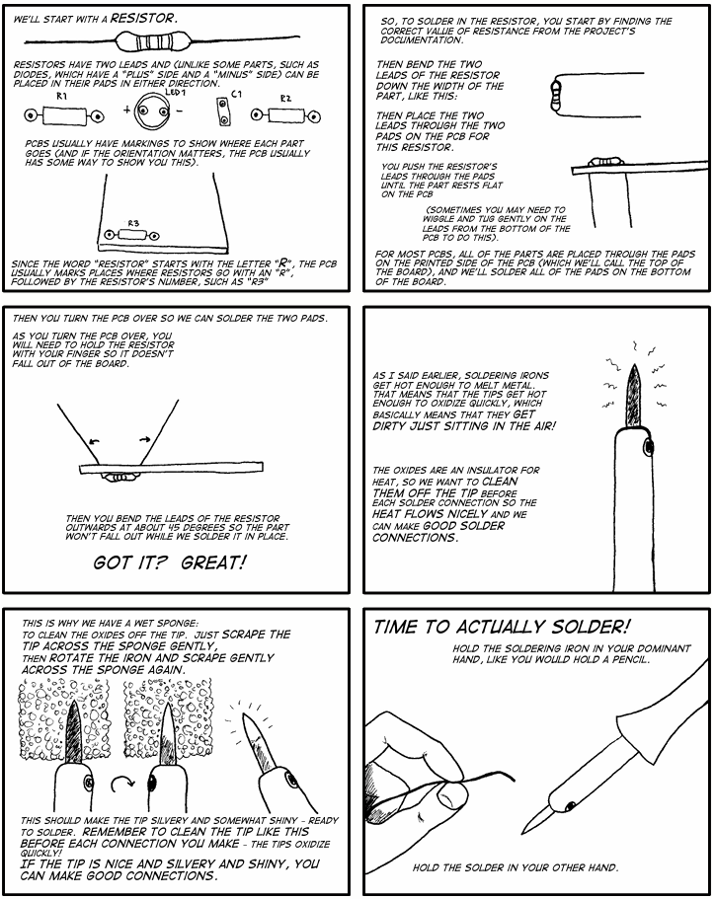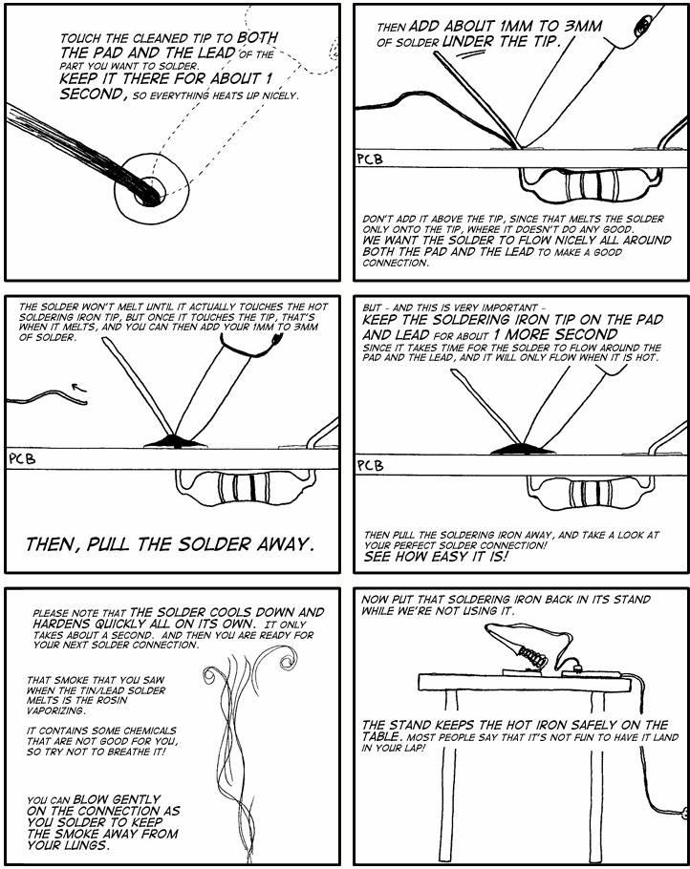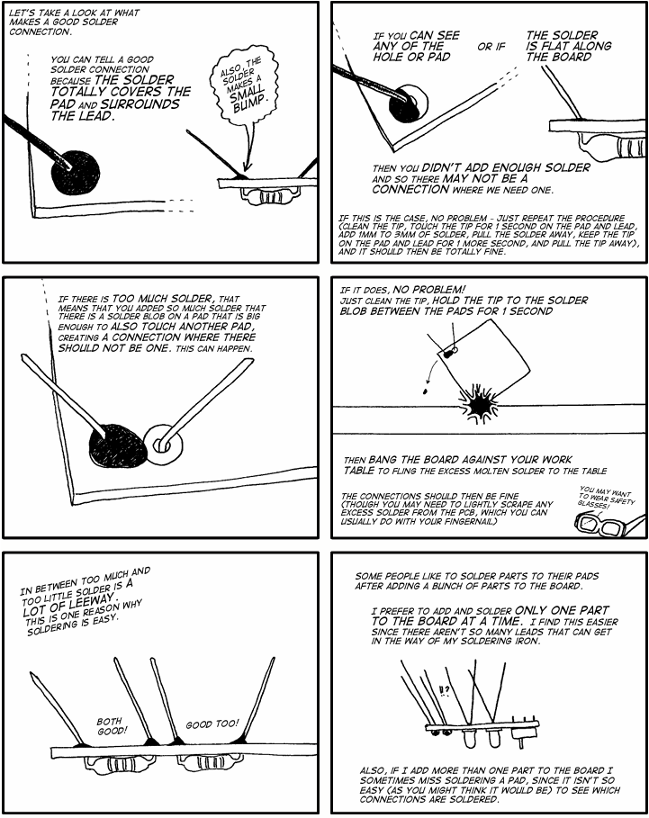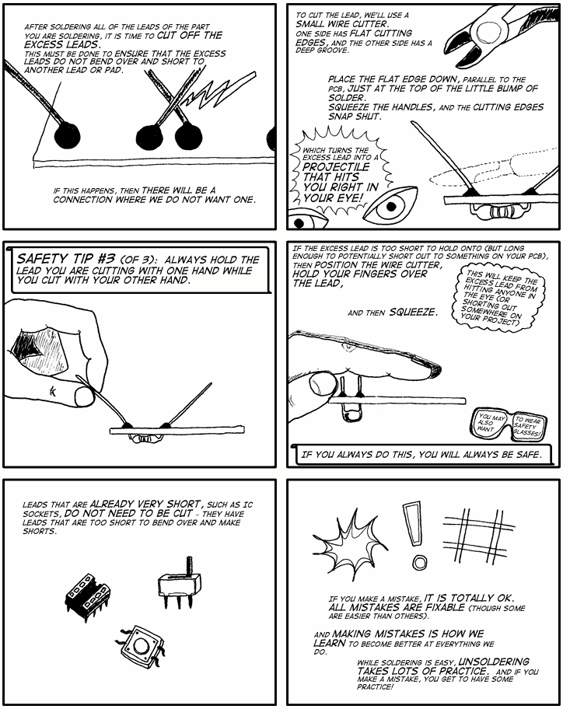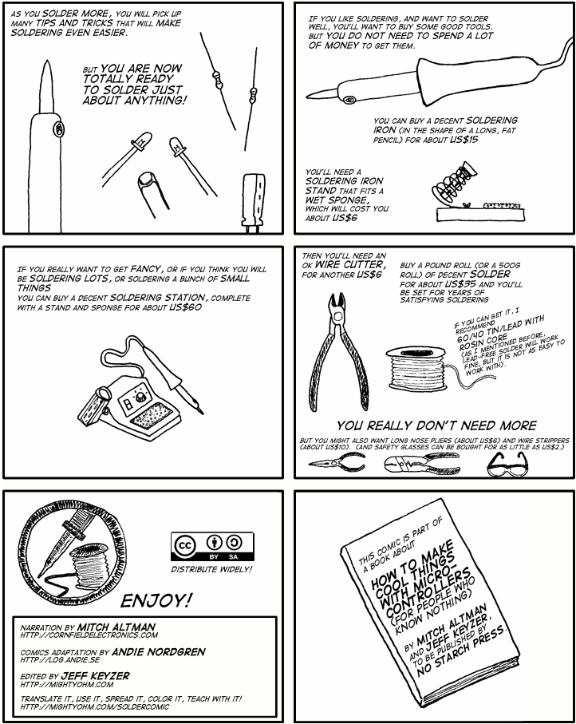

Resistor Colour Code Wheel

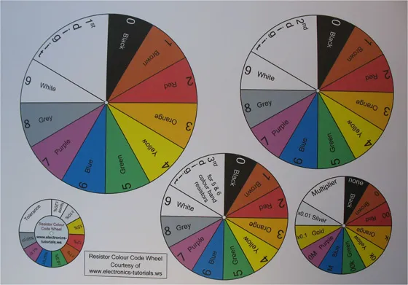

Resistor Colour Code Wheel for Resistor Colour Codes

How to use https://www.electronics-tutorials.ws/resistor/resistor-colour-code-wheel.html

Using this booklet
This booklet is written for Scouts and Explorers aged approximately 10 to 16. It introduces beginner electronics in small steps and is designed to be used with an adult Leader. Ask for help whenever you are unsure, especially when using a soldering iron, drill, sharp cutters, batteries, or a multimeter.
The activities in this booklet are intended for low-voltage battery circuits only. Do not connect a project to mains electricity, a wall socket, a vehicle battery, or any unknown power supply. A Leader should check each circuit before power is applied.

Badge requirements at a glance
Requirement 1 — Components and functions: use the Component Types, Basic Electronics Theory, and Circuit Projects sections.
Requirement 2 — Markings and ratings: use The Colour Code of Resistors, capacitor markings, and the Ratings and datasheets section below.
Requirement 3 — Symbols, diode polarity, and IC pin numbers: use Schematic Diagrams and the Pin identification section below.
Requirement 4 — Safe working: read Safety First before handling parts, circuit boards, tools, batteries, or soldering equipment.
Requirement 5 — Multimeter measurements: complete the Using a Multimeter activity with a Leader.
Requirement 6 — Analogue and digital circuits: compare the examples in Analogue and Digital Electronics.
Requirements 7 to 9 — Three circuits, operation, typical values, and uses: complete the three Circuit Projects and record your results.
Requirement 10 — Uses and benefits: discuss the Everyday Uses of Electronics section and give examples of how electronics can improve people’s lives.

Safety First
Work only under the supervision of a Leader. Use a tidy, well-lit work area with a heat-resistant surface. Keep drinks, food, loose paper, and flammable materials away from the workbench. Tie back long hair and avoid loose sleeves or jewellery.
Disconnect the battery or power supply before changing wiring. Never assume a circuit is unpowered: check it with a voltage measurement when a Leader says it is appropriate. Do not place a multimeter set to current directly across a battery or power supply.
Wear eye protection when cutting component leads or drilling. Hold small parts with clips or pliers rather than your fingers. Keep the soldering iron in its stand when it is not in use, never touch the metal tip, and allow parts and the board to cool before handling them.
Use lead-free solder unless a Leader has approved another type. Wash your hands after soldering and before eating. Keep solder and clipped wire ends away from mouths, eyes, and younger children. Use suitable fume extraction or good ventilation and keep your face out of the smoke or flux fumes.
If a component, wire, battery, or tool becomes hot, smells unusual, smokes, or behaves unexpectedly, disconnect the power if safe to do so and tell a Leader immediately. Never continue troubleshooting a powered circuit by touching random points.

Ratings and datasheets
A component rating tells you the limits within which it is designed to work. Check resistance in ohms, capacitance in farads, voltage rating, current rating, power rating, polarity, and temperature limits where relevant. A component with a higher voltage or power rating is not automatically a suitable replacement: the value, package, pinout, and function must also match.
For a resistor, the power rating is the maximum heat it can normally dissipate. For a capacitor, never exceed its voltage rating and observe polarity for polarised types such as electrolytic capacitors. For a diode or LED, check both its polarity and its allowed forward current. For an integrated circuit, check the supply-voltage range and the pinout in the manufacturer’s datasheet.

Using a Multimeter
Before measuring, identify what you are measuring and select the correct function and range. Black normally goes to COM. The red lead goes to the voltage/resistance socket for voltage and resistance measurements, and to the current socket only when measuring current. Ask a Leader to check the lead positions before connecting the meter.
To measure voltage, connect the meter in parallel with the part or supply. To measure current, open the circuit and connect the meter in series so that the circuit current flows through the meter. To measure resistance, switch the circuit off and, where possible, disconnect one end of the resistor so that other components do not affect the reading.
Voltage is the electrical potential difference that can drive charge. Current is the rate of charge flow. Resistance opposes current. In a simple resistive circuit, Ohm’s law is V = I × R. Power is P = V × I. Record the units: volts (V), amperes (A), ohms (Ω), and watts (W).

Analogue and Digital Electronics
Analogue circuits use continuously varying voltages or currents. A microphone signal, a light sensor, and a temperature sensor are examples. Digital circuits use defined logic states, commonly described as LOW and HIGH or 0 and 1. Real digital signals still have voltage ranges, noise margins, timing limits, and current limits.
A sensor circuit may begin as analogue and then use a comparator or digital input to make a decision. This is why many real products combine analogue and digital electronics.

Pin Identification
For a diode or LED, look for the manufacturer’s polarity marking. A diode often has a band at the cathode end. An LED usually has a longer lead for the anode when new, a shorter lead for the cathode, and a flat edge or internal shape that may also indicate the cathode. Always confirm with the symbol or datasheet because leads may have been trimmed.
For an integrated circuit, find the notch, dot, or other pin-1 mark. With the notch at the top, pin 1 is normally the first pin to the left and the numbers continue around the package. Do not rely on appearance alone: check the exact package datasheet.

Circuit Projects
Build all three circuits with a Leader. At least one circuit must be mainly digital, and at least one should be soldered on stripboard or a custom-made PCB where this can be done safely. Use only the stated low-voltage supply, check the wiring before power is applied, and record the measured voltage and current for your own components. Values may vary with battery condition, component tolerance, and the exact parts used.

Project 1 — LED and resistor indicator
Purpose: learn polarity, current limiting, voltage measurement, and Ohm’s law. Use a battery pack or regulated supply approved by your Leader, one LED, and a series resistor. The resistor protects the LED by limiting current. Typical beginner values are a few volts of supply and a few milliamperes of LED current; calculate the resistor with R = (supply voltage − LED forward voltage) ÷ desired current.
Operation and use: when the circuit is complete, current flows through the resistor and LED, producing light. Possible uses include a power indicator, a status lamp, or a warning that a switch is on. Measure the supply voltage and the voltage across the LED, then measure the circuit current in series.

Project 2 — Light-sensitive alarm
Purpose: learn about sensors and control. Use an LDR or phototransistor, a transistor or suitable comparator module, a resistor network, and a low-voltage buzzer. The sensor changes the control voltage when the light level changes; the transistor or comparator then switches the buzzer. Use a ready-made module or a Leader-checked schematic if the exact transistor or comparator pinout is unfamiliar.
Operation and use: the circuit can detect light, shade, an open drawer, or a change in room brightness. Record the supply voltage, the approximate buzzer current, and the sensor voltage in bright and dark conditions.

Project 3 — Digital two-input decision circuit
Purpose: meet the digital-circuit requirement by using a logic-gate IC such as a 74HC08 AND gate or another Leader-approved 5 V logic device. Use two push-buttons as inputs, pull-down or pull-up resistors so that the inputs never float, and an LED with a series resistor as the output indicator. Follow the exact IC pinout and supply-voltage limits in the datasheet.
Operation and use: an AND gate produces a HIGH output only when both inputs are HIGH. The circuit can be used for two-button consent controls, a simple safety interlock demonstration, or a game requiring two players to press buttons together. Record the logic input states, output state, supply voltage, and LED current.

Project record

Sections to Flesh Out

Capacitor Markings Activity
Read the marking from left to right and convert between pF, nF, and µF. Practise with examples such as 104 = 100 nF and 472 = 4.7 nF. Also identify polarity markings on electrolytic capacitors and check the voltage rating before use. Complete this activity using real, unpowered components with a Leader.

Component Symbols Worksheet
Match real components to their schematic symbols: battery, resistor, variable resistor, capacitor, diode, LED, switch, transistor, integrated circuit, buzzer or speaker, and LDR. For each one, write its name, function, polarity if applicable, and one common use.

Complete Build Instructions for Three Circuits
Each project sheet should include a circuit diagram, parts list, exact component values, approved supply voltage, assembly method, test steps, expected approximate readings, troubleshooting advice, and a short explanation of how the circuit works. A Leader must check the design before construction.

Multimeter Results Sheet
For each circuit, record the supply voltage, at least one voltage across a component, at least one current measured in series, and any resistance measurement made with the power disconnected. Explain whether the results agree with Ohm’s law and why readings may vary.

Analogue-versus-Digital Comparison Activity
Compare one analogue example, such as an LDR voltage, with one digital example, such as an AND-gate output. Describe continuous values, HIGH and LOW states, thresholds, noise, and one real product that combines analogue and digital electronics.

Everyday Uses and Benefits Discussion
Choose two everyday examples. For each, explain what problem the electronics solves, who benefits, what could happen if it failed, and one issue such as accessibility, privacy, repair, energy use, recycling, or safe battery disposal.

Badge Evidence Checklist

Series and Parallel Circuits
Build or examine one series circuit and one parallel circuit. Record what happens to current and voltage, and predict what happens if one lamp or LED is disconnected. Discuss one everyday use for each arrangement.

Voltage Dividers
Use two resistors or a potentiometer to make a voltage divider. Measure the input voltage and the midpoint voltage, then change one resistance and observe the result. Link this activity to the LDR sensor used in the light-sensitive project.

Component Identification Activity
Work in pairs with a tray of unpowered components. Identify each part, read its markings, find its symbol, state its function, and check whether it has polarity. A Leader should provide the answer key and correct unsafe assumptions.

Multimeter Practical Activity
Begin with a battery and resistor circuit. Measure voltage in parallel, current in series, and resistance with power disconnected. Before each measurement, say aloud which meter socket, function, range, and connection method you will use.

Project Levels and Choosing a Suitable Project
Choose a project appropriate to the Scout’s age, experience, and available supervision. Younger or new Scouts can begin with an LED or paper circuit. More experienced Scouts can build a sensor, motor, reaction game, electronic dice, or digital logic project. The Leader must approve the circuit, supply, tools, and parts before work starts.

Suggested Badge Programme for Leaders
A possible sequence is: introduction and safety; components and symbols; series, parallel, and voltage dividers; first simple circuit; multimeter activity; soldering visual guide; intermediate or sensor project; digital project; project records and badge review. Projects may be spread across several meetings.

Soldering Safety Checklist
Before soldering, check the iron, stand, cable, ventilation, eye protection, board support, component temperature limits, and solder type. During soldering, keep the tip away from skin and cables, keep the joint still while cooling, and use solder wick or a desoldering pump rather than wiping molten solder. Wash hands afterwards.

Electronics Careers and Engineering Pathways
Discuss three areas such as electronic design, embedded software, communications, medical devices, robotics, power systems, test engineering, manufacturing, or repair. For each, identify useful school subjects, training routes, and one way the work can improve people’s lives.
Use this checklist with your Leader: components identified; functions explained; resistor and capacitor values identified; ratings explained; symbols drawn; diode polarity identified; IC pin identified; safe working demonstrated; voltage, current, and resistance measured; Ohm’s law explained; analogue and digital differences discussed; three circuits built; operation explained; typical readings recorded; uses described; and benefits of electronics discussed.
For each circuit, record: the circuit name; a hand-drawn schematic using standard symbols; the supply voltage; at least one measured current; at least one measured voltage; the purpose of each component; what happens when an input changes; one possible real-world use; and one safety check completed before power was applied.

Everyday Uses of Electronics
Electronics is used in communication, healthcare, transport, homes, energy systems, environmental monitoring, accessibility devices, education, and emergency services. Examples include hearing aids, insulin pumps, traffic signals, navigation systems, smoke alarms, renewable-energy controllers, phones, computers, and assistive switches. Discuss both the benefits and the responsibilities: reliable design, privacy, repairability, energy use, recycling, and safe disposal of batteries and electronic waste.

Image and licensing note
Do not create new images for this booklet. Any photographs, diagrams, or illustrations added later should come from the supplied reference material or from a clearly identified Creative Commons or other compatible licence. Record the creator, source, licence, and any required attribution beside the image or in a sources section. Prefer simple, age-appropriate diagrams that explain a component, measurement, or circuit.

Reference Sources and Licensing
The supplied reference set includes the Scouts Electronics Badge Scout Pack and Leaders’ Pack, Electronics, Basic Electronics, Make: Electronics, and Electronics For Dummies. These documents are used as background references for explanations, activity ideas, project progression, and safety review.
Do not copy text, illustrations, photographs, page layouts, or project instructions from copyrighted books into this booklet unless permission has been obtained. The final booklet should use original wording and clearly licensed material only. Images must not be generated for this project. If an existing Creative Commons image is used, record the creator, source, licence, and any required attribution in the booklet’s sources list.
The Scouts UK badge requirements remain the controlling checklist. Reference books can explain beginner concepts, but a Leader should verify every circuit, component value, pinout, supply voltage, and safety instruction before practical use.

STEM Extension Activities
These optional activities can help Scouts work towards other relevant Scouts badges while completing Electronics. They are not additional requirements for the Electronics Scout Badge. A Leader should choose activities appropriate to the Scout’s age, experience, access to equipment, and supervision.

Design, Build, Test and Improve
Choose a practical problem, sketch a solution, select components, build a first version, test it, record what happened, and improve the design. Explain what changed between the first and final versions. This supports a scientific approach and encourages useful engineering habits.

Inputs, Processing and Outputs
For each circuit, identify the input, the processing or control, and the output. Examples include a button or LDR as an input, a resistor network, transistor, logic gate, or microcontroller as the control, and an LED, buzzer, motor, or display as the output.

Digital Citizenship, Privacy and Sharing Projects
If you photograph, publish, or share a project, ask permission first. Do not share a Scout’s full name, address, school, live location, or private contact details. Credit sources and images, use reliable information, and discuss what data the project collects, who can access it, and how it should be protected.

Electronics Experiment Record
Plan one investigation by writing a question and prediction, changing one variable, keeping other conditions the same, recording measurements, comparing the result with the prediction, and explaining what happened. Suitable questions include how LED brightness changes with resistance, how an LDR voltage changes with light, or how a capacitor value changes timing.

Explain Your Results
Present one investigation or circuit to another person using a demonstration, poster, short talk, labelled schematic, or approved digital presentation. Explain the purpose, the science, the measurements, any problems, and what you would try next.

Design a Case or Model for Your Circuit
Design and build a safe case, stand, badge, model building, model vehicle, or control panel for one circuit. Choose suitable materials, measure and mark carefully, protect wires and components, leave access to batteries and switches, avoid sharp edges, and prevent the circuit from shorting against the case.

Test the Finished Model
Test both the electronics and the physical model. Check that the circuit performs its intended function, that the model is stable, that wires cannot be pulled loose, and that batteries and switches can be reached safely. Record one improvement you would make.

Teach Someone Else
Help another Scout identify components, build a simple low-voltage circuit, use a multimeter safely, or follow your project instructions. Work under Leader supervision and focus on explaining clearly rather than taking over the task.

GCSE Electronics Extension Topics
These optional topics are adapted from the UK GCSE Electronics subject content and WJEC Eduqas GCSE Electronics specification. They are included to extend learning for older or more experienced Scouts; they are not extra requirements for the Electronics Scout Badge. A Leader should select only activities that are suitable for the Scout, equipment, and supervision available.

Electronic systems: inputs, processing and outputs
Describe a circuit as a system with an input, a processing or control stage, and an output. For example, an LDR or switch can provide the input, a voltage divider, transistor, comparator, or logic gate can process it, and an LED, buzzer, motor, or lamp can provide the output. Discuss where a transducer changes a physical quantity such as light, sound, or temperature into an electrical signal.

Power, energy and SI units
Extend the multimeter activity by calculating power with P = V × I. Where appropriate, discuss energy using E = P × t, and use correct SI units such as volts, amperes, ohms, watts, joules, seconds, farads, and hertz. Use only low-voltage battery circuits and ask a Leader to check calculations before changing a circuit or power source.

Resistor combinations and voltage dividers
Compare resistors connected in series and in parallel. Predict whether the combined resistance will increase or decrease, then test the prediction with a multimeter when the circuit is unpowered. Use a two-resistor voltage divider to investigate how the midpoint voltage changes when one resistance changes, linking the activity to the LDR project.

Logic gates and truth tables
Create truth tables for NOT, AND, OR, NAND, and NOR gates using 0 and 1 or LOW and HIGH. Compare the truth table with the behaviour of the digital two-input project. Older or more experienced Scouts may identify the gates in a logic IC and check its pin 1 mark and supply limits using the datasheet.

Specification, testing and evaluation
Write a short specification before building: what the circuit must do, its supply voltage, inputs, outputs, approximate current, size, and safety limits. Test each requirement, record measured results, identify any failure or unexpected behaviour, and propose one improvement. This develops the design-and-evaluation approach used in GCSE practical work.

Optional advanced topics
With suitable equipment and supervision, a Leader may introduce transistor switching, diode applications, timing circuits such as a 555 timer, operational amplifiers, or simple digital-to-analogue examples. These topics are enrichment only and should not displace the beginner explanations or practical evidence needed for the Electronics Scout Badge.

Leader Cross-Badge Activity Map
The table below shows how activities and information in this booklet may provide evidence for other badge work. Leaders should check the current official badge requirements and decide whether the evidence is sufficient for the individual Scout. The Electronics Badge remains the primary purpose of this booklet.
Badge or extension | Booklet activity or information | Possible evidence | Leader check
Digital Maker | Design, Build, Test and Improve; Inputs, Processing and Outputs; Digital Gadget Challenge; Complete Build Instructions | A working digital device, identified inputs and outputs, code or control method where used, testing notes, improvements, and instructions another person can follow | Confirm the activity meets the relevant Digital Maker stage and that any device or code is suitable and safe
Digital Citizen | Digital Citizenship, Privacy and Sharing Projects; Reference Sources and Licensing | Safe sharing plan, privacy decisions, source checks, image credits, and responsible handling of project data | Check consent, privacy, copyright, attribution, and approved platforms
Scientist | Electronics Experiment Record; Series and Parallel Circuits; Voltage Dividers; Multimeter Practical Activity | Question, prediction, controlled variable, measurements, result, explanation, and reflection on improvements | Confirm the Scout planned, tested, recorded, and explained the investigation
Model Maker | Design a Case or Model for Your Circuit; Test the Finished Model | Designed or built model, material choices, construction notes, safe enclosure, functional test, and improvement | Confirm the model is stable, safe, and appropriate to the relevant Model Maker activity
Electronics Scout Badge | Component Identification; capacitor and resistor markings; symbols; safety; multimeter; three circuits; everyday uses | Badge evidence checklist, project record, measurements, explanations, and Leader discussion | Check all ten Electronics Badge requirements against the current official wording
Cross-badge presentation | Explain Your Results; Teach Someone Else; Electronics Careers and Engineering Pathways | Demonstration, talk, poster, peer instruction, or approved digital presentation | Record what was presented, to whom, and which badge activity it supports
Creative Commons and source practice | Image and licensing note; Reference Sources and Licensing | Creator, source, licence, attribution, and permission record for reused material | Confirm no generated or unlicensed images, text, layouts, or project instructions were copied

